INTERIM PROJECT REPORT

**PROJECT NAME: Unix Shell and History Feature**

**GROUP MEMBERS:**

* Farhan Irfan
* Zohair Adil Khan
* Abdul Haseeb
* Taha Ahmed Zaidi
* Arsal Khan

We implemented the following features of our project for the interim presentation.

1. String input command and it’s execution.
2. Running program in background with the help of parent child processes.
3. Showing history of input commands by entering history.
4. Showing error message when input the wrong command.

Below are the screenshots of the above features.

* We can enter the valid command as input in program and it will run it just like the real terminal do.

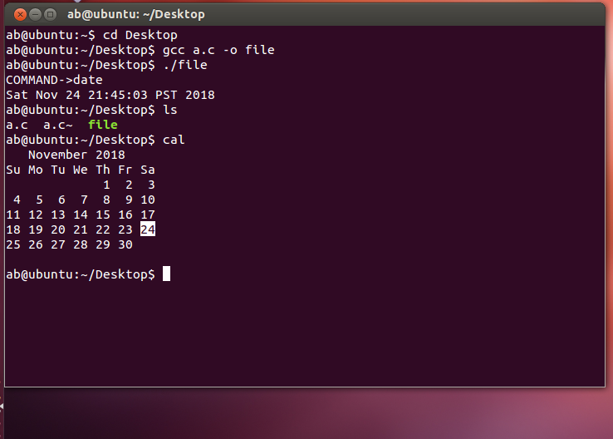

* We can see the last 10 commands in the history we created by entering the history command in it.

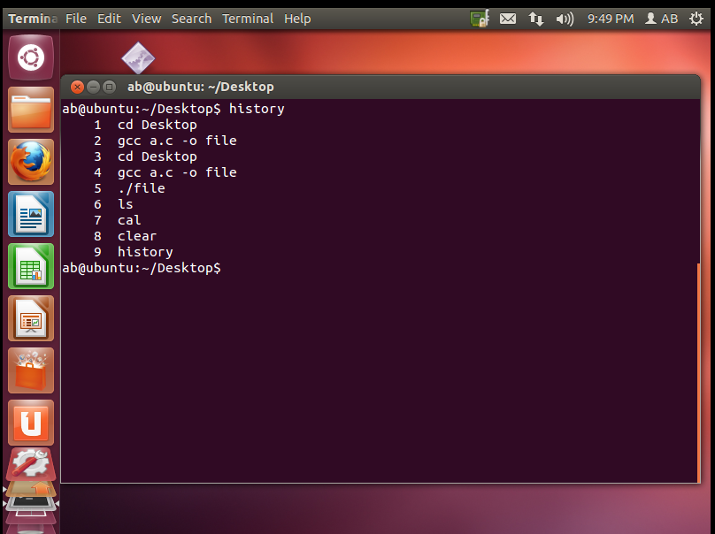

* We can run two programs at the same time by adding “&” sign in the command and we can also run command with “&” sign but now it will wait for the second program to finish to run the first program again.

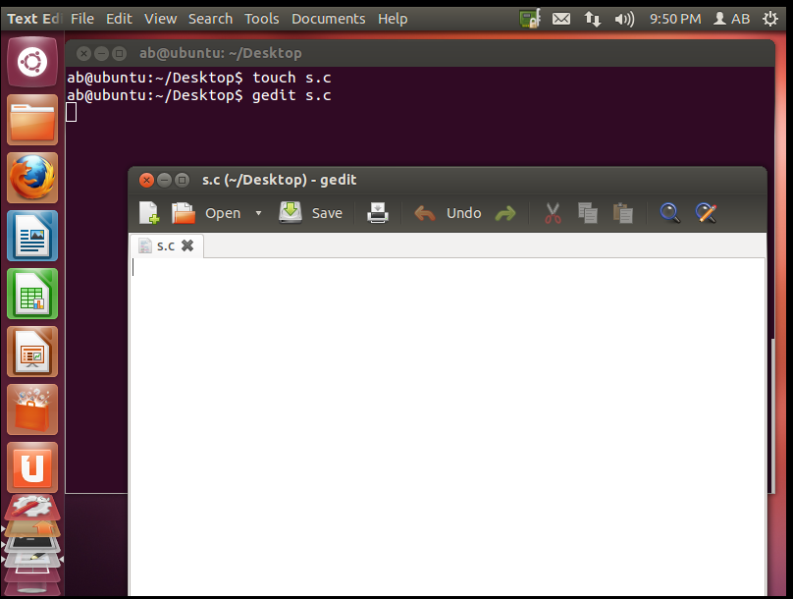

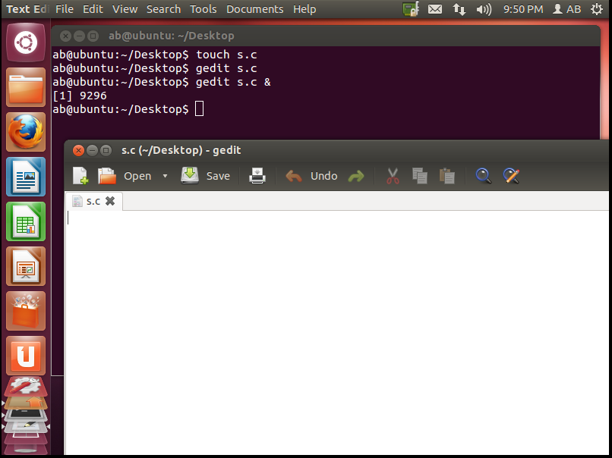

* We can see the error message when we type wrong command.

